Postman Testing

Endpoint: https://fastapi-1-13ev.onrender.com/app
GET /app: Successfully accessed the frontend page from the deployed application (200 OK).

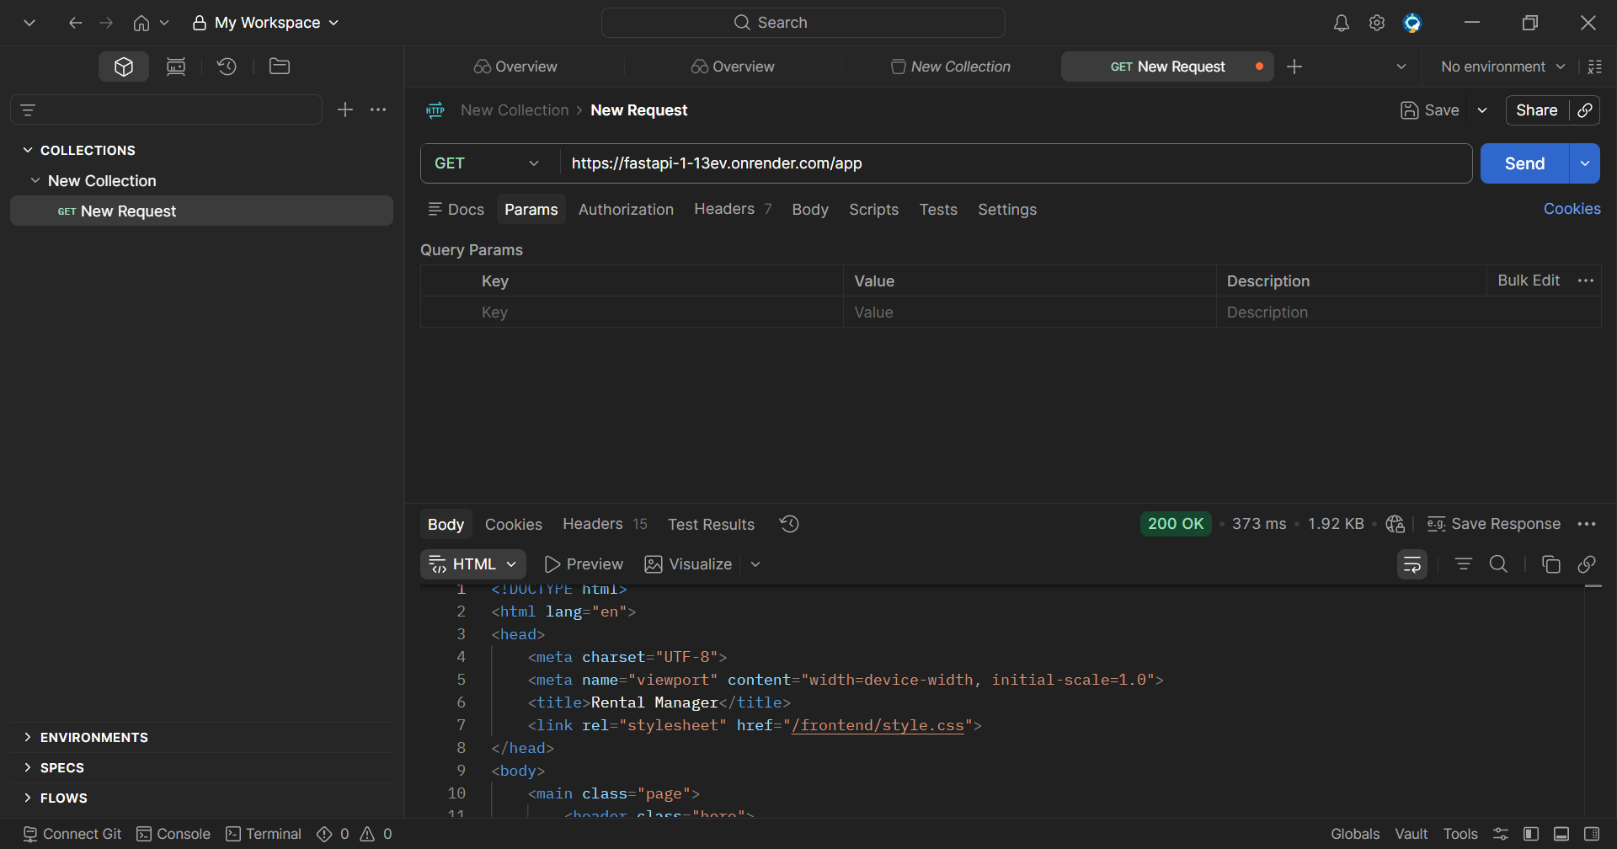

POST /login: Successfully authenticated the user and generated a JWT access token for accessing protected routes (200 OK)
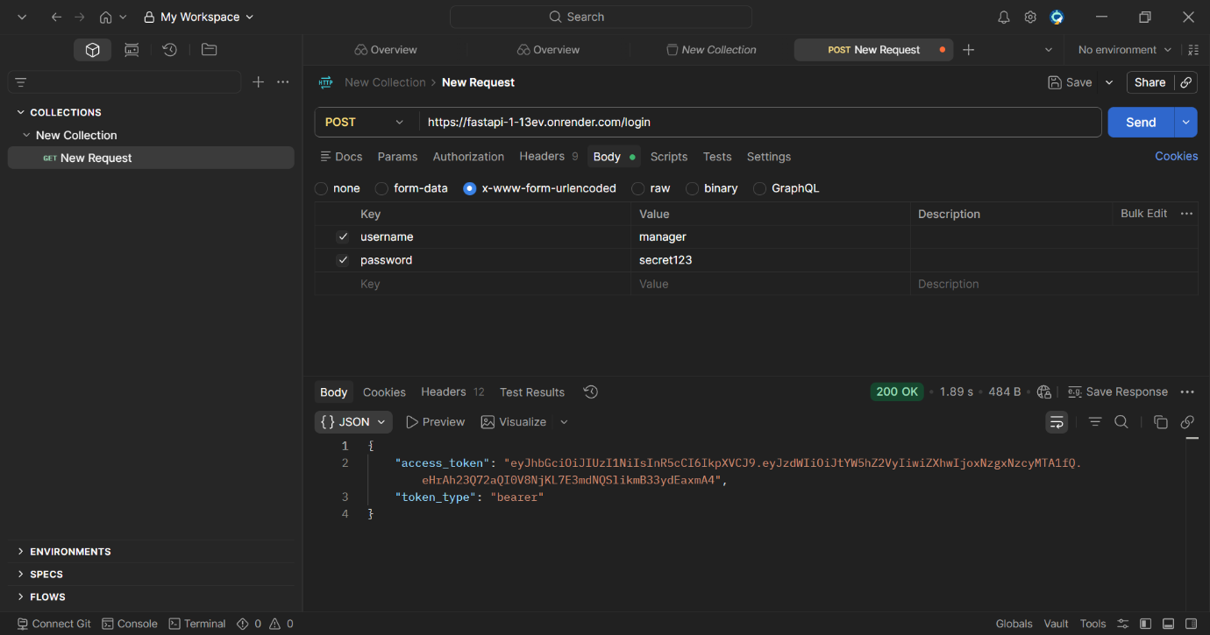

POST /rentals: Successfully added a new rental property record to the database (201 Created).
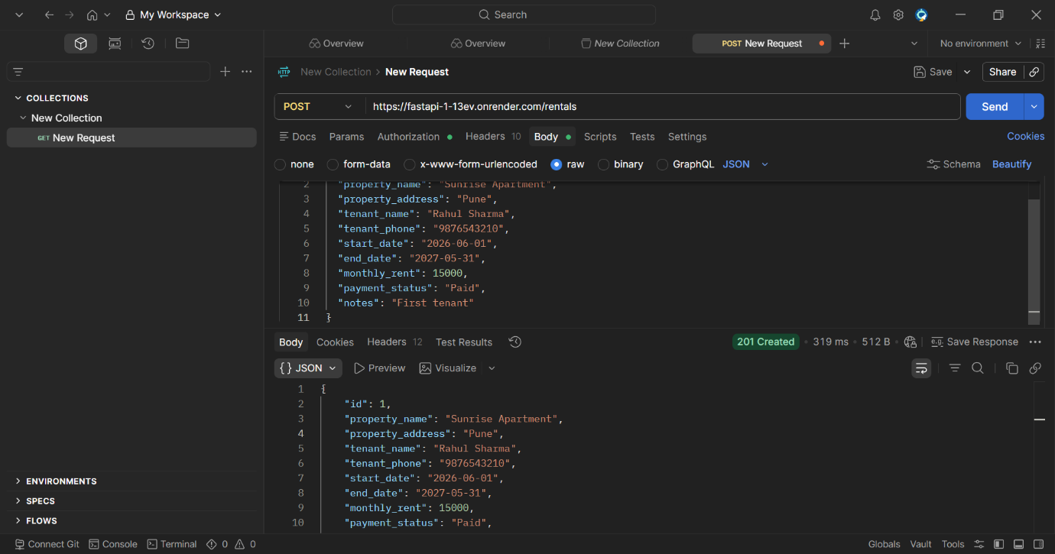

GET /rentals: Successfully retrieved rental property records from the database using JWT authentication (200 OK).

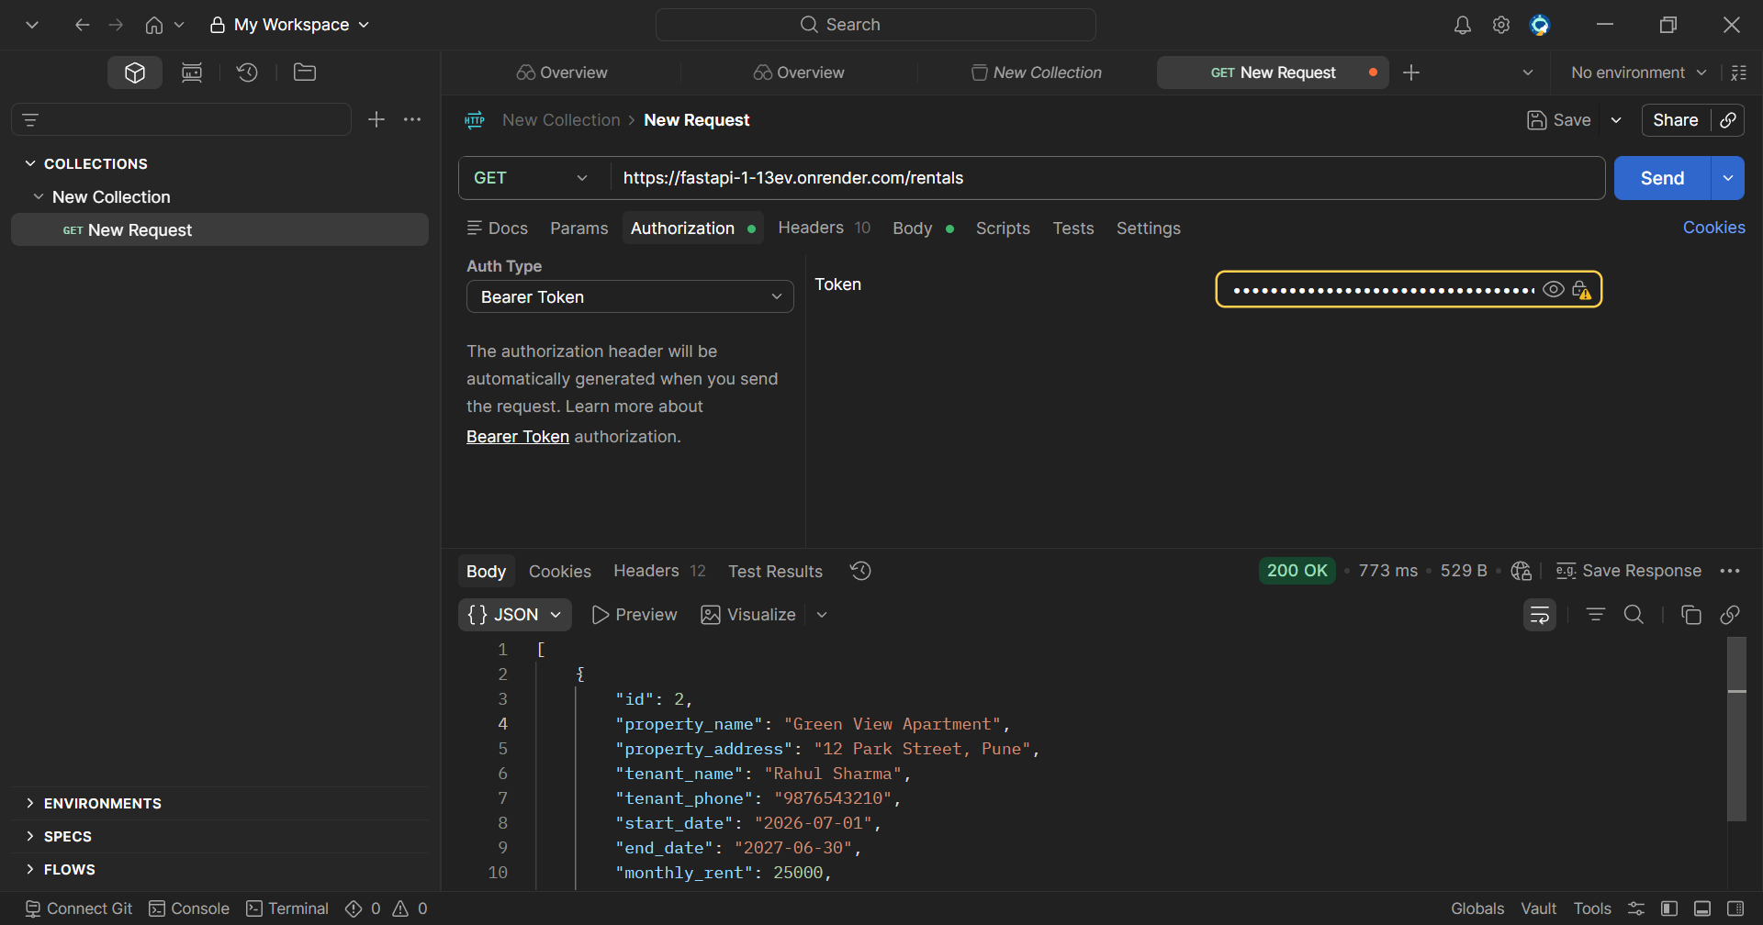

PUT /rentals/{id}: Successfully updated the rental property record in the database (200 OK).
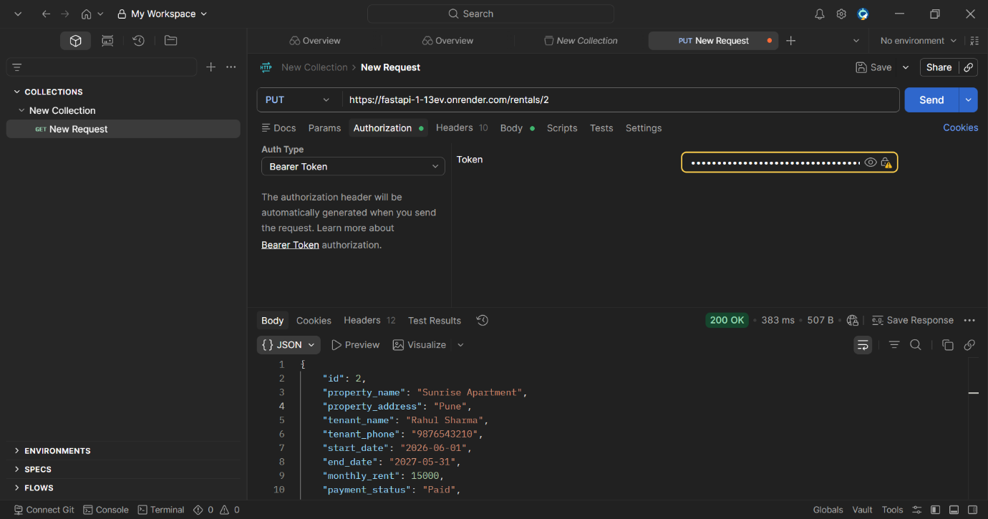

DELETE /rentals/{id}: Successfully deleted the rental property record from the database (200 OK).
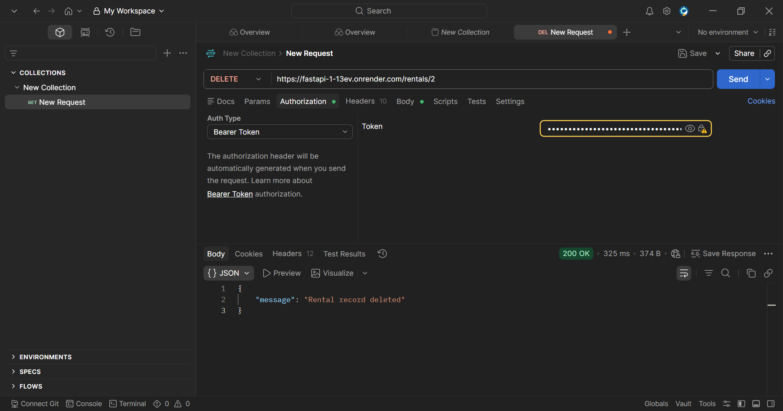

The Property Rental Management System was successfully deployed on Render and tested using Postman. JWT authentication was verified through the Login API, and all CRUD operations (Create, Read, Update, Delete) were successfully performed on rental records. The API responded with appropriate status codes, confirming the correct functioning of the application.

